Leadership in a Digital Age

LD7090

Busra Ecem Sakar

Student Number: 22065255

**Table of Contents**

**1.** **Section 1: Leadership Models/Theories** 2

**1.1** **Trait Theory** 2

**1.2** **Contingency Theory** 3

**2.** **Section 2: Self-Analysis** 4

**3.** **Section 3: Leadership Capabilities and Behaviours in Leading a Virtual Team** 9

**4.** **Section 4: Business Transformation** 12

**5.** **Section 5: Personal Development Plan** 14

**References:** 16

**Figure 1. Contingency Model (Fiedler, 1967, cited by Dubrin, 2022).** 4

**Figure 2 Personality Insight Results** 5

**Figure 3. Workplace culture** 6

**Figure 4. Learning Styles** 6

**Figure 5.Temperament** 7

**Figure 6. Self-assessment report result** 7

**Figure 7. Self-assessment report detail result** 8

**Figure 8. Personal Swot Analysis** 9

1. **Section 1: Leadership Models/Theories**

To effectively transition to a digital world, there is a growing demand for digital leaders, and this era of digitalization has highlighted the need for digital leadership even more. Many firms today require a leader with the expertise and abilities to carry out the digitization process since it has become necessary. Leadership is recognised as a critical component of company success in the digital revolution. Theories of digital leadership will be discussed in this section.

According to King (1990), In terms of the leadership thought process, each new era symbolises a more advanced stage of development than the one before it. Table 1 provides instances of specific beliefs together with information on the major leadership eras and periods. This section will be focused on Trait Theory and Contingency Theory.

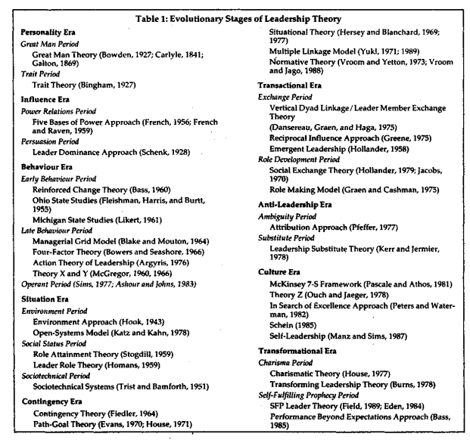

## **Trait Theory**

The concept of the "great man" in leadership was progressively displaced by the "trait theory" as social scientists began to conduct research that looked more closely at the traits of leaders at the turn of the 20th century. As leadership studies have progressed from the concept of "great man" to "trait theory," topics like physical qualities, personality traits, and skills have been the focus of research since the turn of the 20th century, and between 1920 and 1950, research into the leadership qualities theory accelerated thanks to the invention of psychological tests (Yukl, 1989). Trait Leadership theories place a strong emphasis on individual traits (Robbins, Judge, 2018).

The primary objective of the majority of the early research that fell under the ambit of the trait theory was to compare leaders and non-leaders in order to ascertain what kinds of distinctions, if any, exist between them in terms of physical traits, personalities, and talents (Yukl, 1989). Successful and unsuccessful leaders were compared in several studies in an attempt to identify what traits contributed to their success. Many studies have been done that involve psychological factors like intelligence and the drive to succeed, in addition to personality traits like gender, height, and physical appearance. It has been noted that the majority of research conducted for this purpose took place between 1930 and 1950.

According to Yukl (1989), a leader needs to be creative, organised, persuasive, diplomatic and sensitive, knowledgeable about the issue at hand, and able to talk clearly.

Lists the following qualities are added that a leader should have:

1. **Personality;** independence, self-assurance, excitement, honesty, and moral rectitude. awareness, originality, emotional equilibrium, and self-control (nonconformity)
2. **Social skills;** sociability, interpersonal abilities, cooperativeness, capacity for cooperation establishment, and capacity for tact and diplomacy
3. **Physical characteristics;** Energy (energy) and physical endurance (physical stamina)
4. **Intelligence,** Intelligence/intelligence, Cognitive ability (cognitive ability), Knowledge (knowledge), Judgement (judgement), Decisiveness (decisiveness), Language fluency (fluency of speech);
5. **Work-related qualities**, such as a desire to succeed and achieve goals, as well as being methodical, careful, conscientious, persistent, and tenacious in pursuing goals. (Halaychik, 2016)

The identification of leadership potential in persons is made possible by trait theory. This theory has received a lot of criticism for its oversimplification and for leaving out numerous other factors, however, it is applied by many firms to aid in recruiting decisions. The theory's critics contest the notion that those who possess these traits become effective leaders while those without them are ineffective. Trait theory's significance appears to have changed throughout time. It might be argued that the improvement of learned abilities and environments makes natural qualities more significant.

## **Contingency Theory**

The development of leadership theory has made significant strides thanks to contingency theory. For the first time, it was understood that leadership did not exist in any of the purely one-dimensional forms that were previously explored but rather comprised aspects of all of them, and in essence, behaviour, personality, influence, and circumstance were all necessary or necessary for effective leadership, depending on one or more of these elements. The typical leadership strategies of the time sought to identify the situational moderator characteristics that would most clearly indicate which leadership style to employ (King, 1990).

Fred Fiedler, one of the founders of the contingency leadership theory, illustrates how good circumstances and leadership style (style of leadership) are related (favorableness of the situation). The leader obtains their position of authority through formal channels, and their leadership style is task- and people-directed. Fiedler divides the situation's favorability into the following three dimensions: the leader-member relationship; the degree of task structure; and the leader's position power (Ayman, Chemers, Fiedler,1995)

The scenario modifies the impact of a leader trait known as the least preferred coworker (LPC) score on group performance, according to Fiedler's (1967; 1978) LPC Contingency Model. If connections need to be improved, a high LPC leader will behave in a thoughtful, encouraging approach. Only after the major affiliation motivator has already been satisfied by intimate, personal ties with employees will the fulfilment of task accomplishment become relevant. When task issues develop, a low LPC leader would prioritise task-oriented behaviour because task objectives serve as their primary source of motivation (Yukl, 1989).

Figure 1 is shown that, according to contingency theory, in these two circumstances, leaders with low LPC scores—those who are highly driven by their current tasks—will perform best. Additionally, leaders with middle LPC scores will function successfully in Position 1 as well as under somewhat less favourable conditions (Figure 1, positions 2 to 3). Lastly, leaders with a high LPC score (highly relationship-oriented) will be most effective in circumstances that are moderately advantageous to somewhat less favourable (Positions 4 to 7 in Figure 1) (Dubrin, 2022).

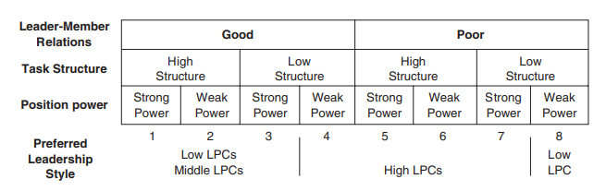

**Figure 1. Contingency Model (Fiedler, 1967, cited by Dubrin, 2022).**

# **Section 2: Self Analysis**

* **Personality Insights:**

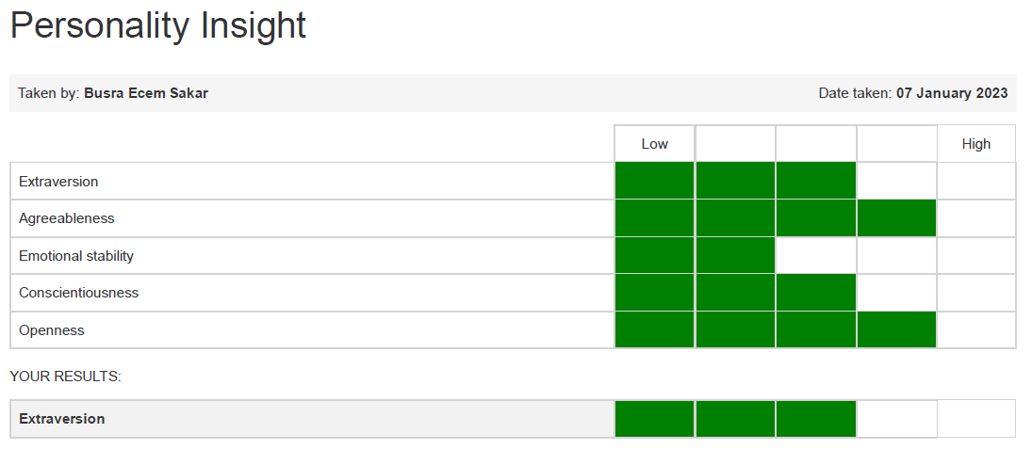

**Figure 2 Personality Insight Results**

Based on report result that is shown Figure 2;

I am in the mid range on Extraversion, which means I am likely to be comfortable with others, but may also need to balance this with time alone. I have to check that any jobs I consider will bring me into contact with a variety of people, but that I will also be able to have time alone to think, reflect and work at my own pace.

I have scored low on Emotional Stability, which means I am prone to stress and pressure. So, I can identify the high-pressure roles and ask people in them what their coping strategies are.

I scored high on Openness. I am likely to be receptive to new experiences and novel ways of doing things which digital team leaders needed.

* ***Workplace culture:***

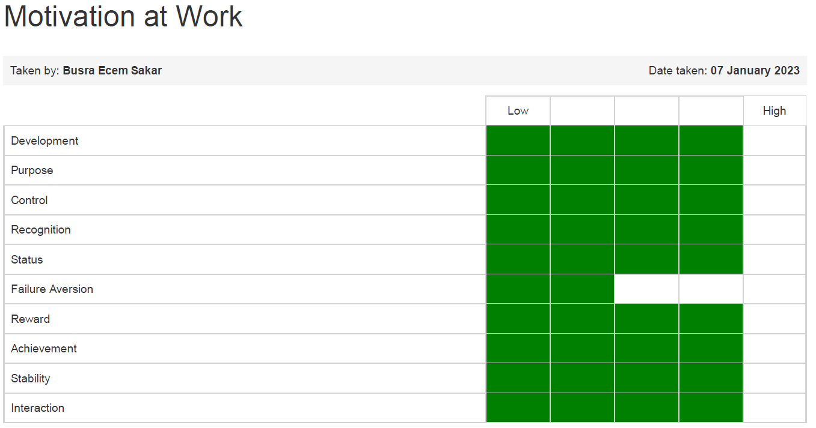

**Figure 3. Workplace culture**

Based on report result that is shown Figure 3;

I have a high score on development. I am likely to put more time and effort into my work when I see opportunities to learn and develop motivates me to complete activities that I expect to increase my knowledge and skills. This subject is also essential for digital leadership.

On the other hand, I have scored low on failure aversion, which suggests: I tend to stop trying when faced with failure the prospect of being criticised makes me reduce my efforts my motivation to work decreases.

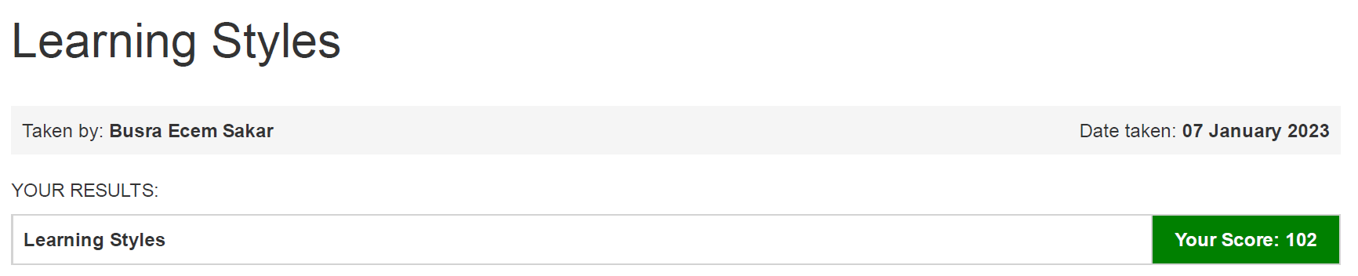

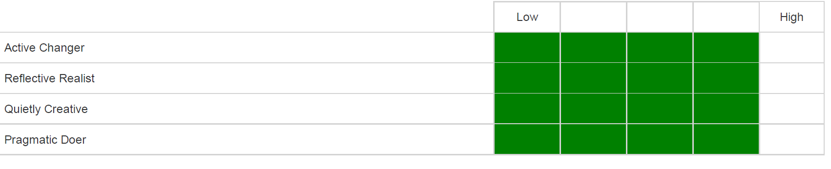

**Figure 4. Learning Styles**

I have a 102 score from learning styles, which means that, I am a highly motivated learner who employs a wide range of approaches to learning. I take advantage of opportunities to learn through doing and reflecting, through established approaches and new ideas.

This score is important to become a digital leader. Because in the digital workplace, people have to improve themselves almost daily.

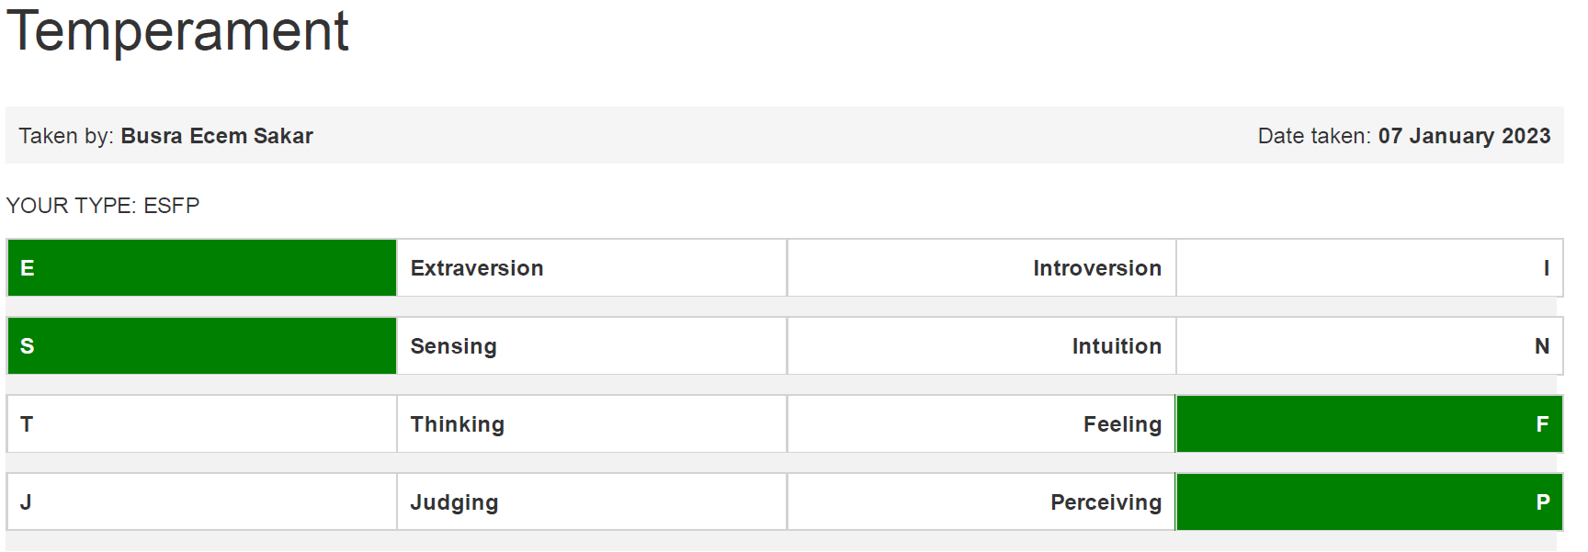

**Figure 5.Temperament**

My type from ESFPs are spontaneous, fun and optimistic and have excellent. I love to perform and be the centre of attention and are very good at stimulating other people’s senses. I am generous and warm, very observant about other people and frequently play the peacemaker. I am usually very practical, but hate structure and routine, preferring to go with the flow.

ESFPs need variety, freedom and independence, but prefer to work in a group.

* ***Employability Self­-assessment***

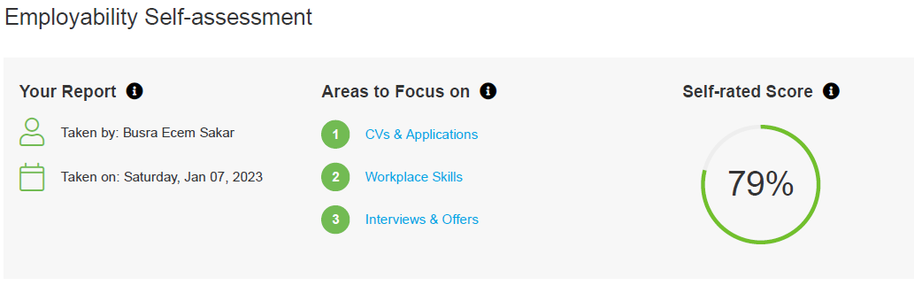

**Figure 6. Self-assessment report result**

According to self-assessment report results, as is shown Figure 2. My self-rated score is 79% which means that, I am well-versed in some of the key elements influencing my employability. I have to focus on CV’s & Applications, Workplace skills and Interviews & Offers.

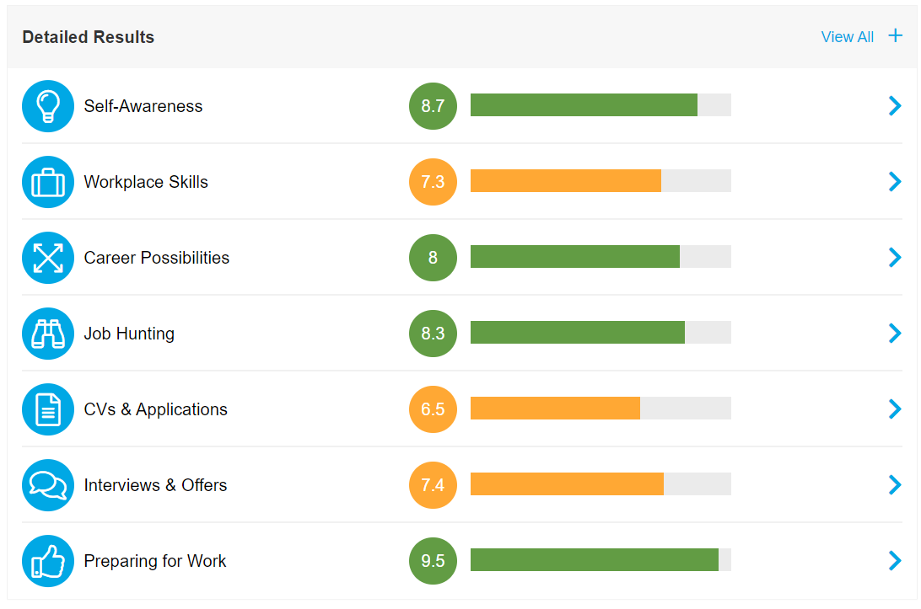

**Figure 7. Self-assessment report detail result**

Depending on the result I need to be able to (Figure 3):

*For improving workplace skills;*

- Specify the requirements for a choice, produce a range of options, and choose the best one.

- Be completely conscious of the effects of my voice and body language while preparing for and giving a presentation, using visual aids, and presenting.

- Get ready for negotiation, start a negotiation, conduct it, and close it.

*I need to be fully aware of the following in order to improve my CV and application skills:*

- How to organise and arrange my resume to appeal to a variety of businesses - Which areas I need to fill out, the most relevant details to include, and what to emphasise

- How to optimise my CV for search engines and make the content interesting to employers Candidate Monitoring Systems

- How to create a speculative application; - How to write an effective application and cover letter.

*I must be fully confident regarding interviews and offers if I'm to:*

- The preparation I must complete regarding the fundamentals, what I have to offer, the employer, and practising for the particular type of interview I will encounter

- The more typical interview questions and how to effectively communicate my strengths, skills, and experience through the way I respond to them

* ***Personal SWOT analysis***

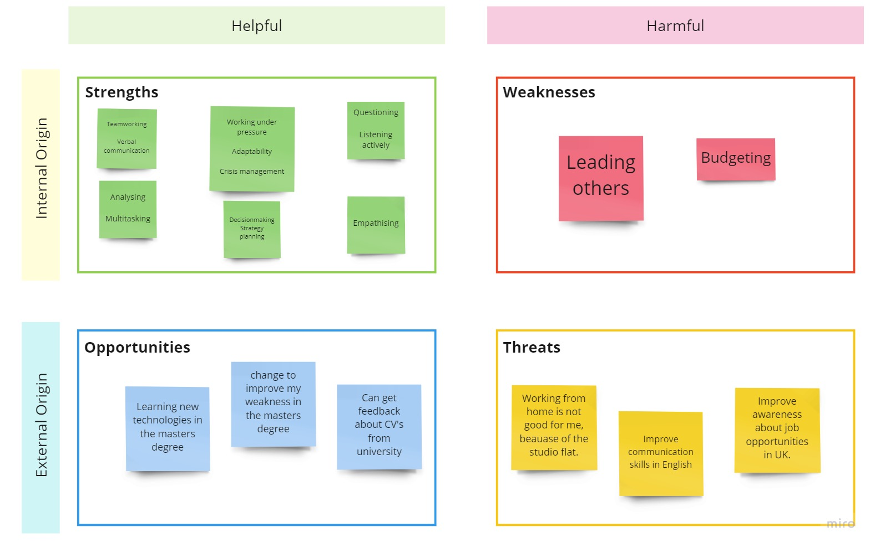

**Figure 8. Personal Swot Analysis**

# **Section 3: Leadership Capabilities and Behaviours in Leading a Virtual Team**

Over the past 20 years, the number of people working from home has gradually increased, and virtual teams have followed suit. In just a few short weeks, the COVID-19 pandemic-related worldwide catastrophe has led distant collaboration to soar to arguably its highest level ever. As a result of this sudden rise in virtual teams, there has been a quest for management strategies that can preserve both productivity and employee well-being, providing some stability in these turbulent times. Leading a virtual team requires more complicated leadership abilities. A leader of a virtual team must be able to motivate and inspire their team without really meeting them, without seeing them every day, and without being able to physically demonstrate suitable and desirable behaviour.

Effective leadership qualities are essitional and needed for a virtual team. Below is a discussion of a few of the specific virtual leadership competencies (Mogale, 2010).

1. **Capacity to establish trust:**

The most crucial leadership talent to learn is how to create, maintain, and defend relationships of trust. Trust is crucial in a virtual setting. Because goodwill is challenging to gauge in a virtual context, trust in virtual teams is frequently founded on deeds rather than goodwill (Jarvenpaa & Leidner, 1999).

Effective teamwork depends on effective communication between individuals. Virtual Team Leaders have a responsibility to demonstrate to the other team members their dedication and dependability.

1. **Demonstrate empathy:**

Cultivating empathy is essential for being an effective leader of a virtual team. Leaders must be aware of the difficulties employees confront in carrying out their business at each site and provide them with the necessary support. Each group will encounter unique challenges. For some, this will be completing the task in the allotted time, for others, meeting times may be a problem if they are collaborating across time zones. To achieve the best project outcomes overall, it is necessary to comprehend and correctly handle the issues faced by each group. To comprehend that each person needs a different kind of help, empathy is necessary.

1. **Communicate proactively:**

Although effective communication is always crucial, it becomes even more important when managing remotely. Messages need to be repeated by leaders because they risk being forgotten if they are not seen. Verbal communication is more prevalent when there is no physical contact and no use of body language. Leaders must use video conferencing, pick up the phone, and offer video updates. Email need to be used only to reinforce messages.

For instance, there are more effective ways to interact online, even while email facilitates communication within your firm. To assist you in immediately connecting with peers, recommend using platforms like Slack, Zoom, and Microsoft Teams. Through direct messaging and video calls, these services offer a terrific way to instantly communicate with team members.

1. **Set definite goals and expectations:**

A higher level of freedom and accountability is needed when working remotely. It is crucial in a remote setting to ensure that everyone is aware of the vision, goals, and purpose. Having a broad perspective affects performance. The best teams have straightforward, attainable goals that they constantly assess and discuss.

Individual self-regulation is enabled and supported by clear objectives, visions, and instructions. They also make it possible for team members to keep track of and assess their own performance. The provision of such transparency is unquestionably pertinent and crucial for project success in a virtual environment (Kurt,2010).

Setting clear expectations is one of the best strategies to enhance communication in virtual teams. Members will understand exactly how to succeed at work if the leader set expectations early. For instance, let your personnel know up front if you anticipate them being online at 9 AM. It will be easier to avoid misunderstandings and poor communication if you have clear expectations.

1. **The capacity to inspire and drive:**

In a remote or hybrid work environment, it can be more difficult to assist your team in discovering their "why". Simply said, when everyone is geographically separated, connecting requires more thought and effort.

Inspiring virtual leaders should put these five strategies into practice; Become tech-savvy, be human, foster cooperation, be truthful and reasonable, and listen.

1. **The capacity to consistently provide input:**

Evidence suggests a connection between feedback and performance—specifically, that giving detailed feedback is crucial to building and maintaining trust and a high-performing team. Working remotely makes it difficult to remember to recognise the accomplishments and victories of the team. Although shaking hands in person is impractical, there are alternative ways to acknowledge and appreciate achievements.

For instance, scheduling a 15 to 20-minute touch base once a week is plenty to provide constant feedback and keep track of mood. One-on-one meetings are ideal for receiving feedback and making sure your message is conveyed in the appropriate manner. These meetings are also a great opportunity to assess the development of each team member and identify any possible areas for development.

Additionally, the company's recognition of team members is demonstrated to employees through the employee of the month programme. The organisation recognises a team member every month for outstanding accomplishments, a great attitude, teamwork, and above-and-beyond efforts. Compared to regular office environments, virtual teams tend to receive these accolades less frequently. However, you can and should recognise exceptional workers from a distance, particularly because virtual work often goes unnoticed by colleagues.

# **Section 4: Business Transformation**

Digital capabilities are applied to processes, goods, and assets in order to boost productivity, raise customer value, control risk, and open up new revenue streams.

Adopting a mindset of continuous innovation and quality improvement is a crucial part of the process.

In this chapter, the digital transformation of fashion will explain in six steps;

1. ***Possess a Plan of Action***

According to the aforementioned McKinsey & Company analysis (Gonzalo, A. *et al.* 2021), consumer purchase intent plummeted by between 70% and 80% in physical stores in both Europe and North America at the beginning of the pandemic. The pandemic forced most people to stay at home, which encouraged customers to explore alternative purchasing options. In this circumstance digital transformation is essential. Making a plan before taking an action is efficient. Some steps are shown below:

* Get data from open sources to analyse fashion market needs
* Analyse marketing neededs
* Analysthe e what needed for a transformation
* Create an effective team that works on transformation

1. ***Fill Technical Gap***

Fashion brands can employ digital technology to either develop new consumer experiences and business processes or enhance their current ones. This is known as "fashion digital transformation."

Actions are shown below to fill the technical gap.

* Open a virtual store
* Prıduct ranking, discount, offers, personalisation email campaigns and home pages
* Create communication platforms like WhatsApp

1. ***Pose effective queries***

It's crucial to sit down with key personnel and do a pain point assessment, which involves looking at every aspect of the company to determine what functions well and what doesn't.

Where is the current fragmentation in your company?

What is the existing state of affairs, and how does it function?

Where do malfunctions happen in each department of the company?

Does everybody comprehend their position and the company's mission?

The flow of information is how well?

Does the business need to eliminate errors or improve customer service?

Is internal communication within the organisation lacking?

Is the business struggling to satisfy orders or losing customers to rivals?

Additionally, take a sincere look at the company's current technology, data usage practises, and any skills, resource, or buy-in gaps for implementing a transformation. Then, consider how better data and digital technologies may benefit organisations. Always keep an eye on how other industries and the company's rivals are utilising technology.

1. ***Understanding Technological Capability***

There are other ways to address problems than using technology. Companies should look at how technology and better data may aid in each aspect of the business as part of a digital transformation, though.

* creating sewing patterns and 3D clothing ideas.
* automating pattern inspections and defect detections in quality control.
* recognising in advance the best- and worst-selling goods. This enables retailers to reduce the output of goods that are still selling well months after their release and raise it for bestsellers.
* It can be challenging to predict which items will sell and which won't in the fast-moving world of fashion.
* A detailed action plan should be made that outlines crucial checkpoints for success as well as the actions the company must take to transform itself in order to reap the most rewards from the technology or data.
* Teams in charge of purchasing and merchandise face the same difficulties.

1. ***Software outsourcing***

By improving their development capacity, software development outsourcing offers a crucial capability that aids businesses in adjusting to the brisk pace of change. By contracting out development work to specialist software development firms, the business may deliver more creative solutions to consumers more quickly (Forsbak, 2021).

1. ***Explore and Measure the Value of Digital Transformation***

Big data and analytics are at the centre of the digital revolution, yet many businesses still find it difficult to translate insights into value-creating data-driven choices. Develop the skills necessary for your business leaders to locate the data they require in order to make the best decisions (Forsbak, 2021).

Monitoring key indicators relevant to business objectives, such as customer value, productivity, and employee engagement, is the best approach to gauge the return on investment for digital transformation (Forsbak, 2021).

# **Section 5: Personal Development Plan**

A virtual team is a collection of individuals who collaborate on shared objectives and projects but do not share a physical workspace. They interact electronically rather than in person, though they may occasionally meet in person.

Becoming a Data Analyst is needed these technological skills (Coursera, 2022):

* *Data-based tools*: Excel is used by almost every industry, SQL can handle bigger data sets and is frequently seen as essential for data analysis.
* *Programming languages*: A Data Analyst can handle massive data sets and solve complex equations by learning statistical programming languages like Python or R.
* *Data visualisation*: Data analysts must be able to clearly and persuasively present outcomes. And have to know how to convey information using charts and graphs effectively. Excel, Tableau, and Jupyter Notebook are available for creating graphics.
* *Math and statistics*: Understanding the principles underlying what data tools actually accomplish will be extremely important. Data Analysts can choose the best tools to utilise to tackle a specific problem, spot mistakes in the data, and have a better comprehension of the outcomes with statistics and arithmetic.
* As a result, these tools are essential.

Microsoft Excel, Google Sheets, SQL, R or Python, Tableau, SAS, Microsoft Power BI, Jupyter Notebooks.

Becoming a Virtual Team Leader is needed these skills:

* *For effective group leadership,*

Creating goals and resolving issues effectively

Building confidence among distant team members and practising collaboration

* *To successfully employ technology,*

what tools to use,

what circumstances require particular tools,

How to pick the right tools for your needs and how to deal with technology problems

* *To understand cross-cultural variation*

How to get beyond cultural barriers,

How to work in accordance with each culture's traditions and daily schedule,

How to reject stereotypes and get rid of bias

Working from home may probably present some of the following difficulties:

* Reduced efficiency and inadequate performance
* Lacking face-to-face interaction leading to a lack of understanding of the tasks provided
* Depersonalization of relationships with coworkers
* And blurring of the barriers between work and home.

To avoid these types of difficulties, a Virtual team leader is needed these skills:

* *Open communication:* Transparency develop trust among team members. Transparent communication can help employees feel anchored in the organisation and the team's work when they are at risk of feeling alone.

Use the best communication technologies such as Slack, Zoom, and Microsoft Teams.

* *Clarify procedures and actions as well as roles and objectives*. Express expectations on goals, roles, activities, and processes in a clear and consistent manner. Because people are working from home, there is a greater chance of distraction or misunderstanding.

Use a task monitoring program, such as Jira, or Monday.com.

* *Flexible working hours:* The entire personnel will rarely be able to work at the same time because they are spread out throughout the globe. Therefore, in order to accommodate multiple time zones and support the team in finding a work-life balance, Virtual Team Leaders will need to be more flexible with their working hours. They will be more content as a result and will work harder.

*Working hours are not important, the important one is the task accomplishment at a particular time.* *Everyone will work more productively if the hours are flexible.*

* *Creating a reward system:*

Making a reward system or meritocratic system that flourishes in a competitive atmosphere is thus the best method to get around this.

Congratulate staff on a public platform for completing a challenging task.

The best employee of the week or month should receive incentives.

Give the top performers time off.

# **References:**

Ayman, R., Chemers, M.M. and Fiedler, F. (1995) ‘The contingency model of leadership effectiveness: Its levels of analysis’, The Leadership quarterly, 6(2), pp. 147–167. doi:10.1016/1048-9843(95)90032-2.

Coursera (2022) *What does a data analyst do? your 2023 career guide*, *Coursera*. Available at: https://www.coursera.org/articles/what-does-a-data-analyst-do-a-career-guide (Accessed: January 7, 2023).

Dubrin, A.J., 2022. *Leadership: Research findings, practice, and skills*. Cengage Learning.

Forsbak, Ø. (2021) *Council post: Leading the digital transformation: Seven tips for CEOS*, *Forbes*. Forbes Magazine. Available at: https://www.forbes.com/sites/forbestechcouncil/2021/09/30/leading-the-digital-transformation-seven-tips-for-ceos/ (Accessed: Dec 13, 2023).

Gonzalo, A. *et al.* (2021) *Fashion's digital transformation: Now or never*, *McKinsey & Company*. McKinsey & Company. Available at: https://www.mckinsey.com/industries/retail/our-insights/fashions-digital-transformation-now-or-never (Accessed: Dec 12, 2022).

Halaychik, C., 2016. *Lessons in library leadership: a primer for library managers and unit leaders*. Chandos Publishing.

Jarvenpaa, S.L. and Leidner, D.E., 1999. Communication and trust in global virtual teams. *Organization science*, *10*(6), pp.791-815.

Johnson, K., 2010. Virtual leadership: Required competencies for effective leaders.

King, A.S. (1990) “Evolution of leadership theory,” *Vikalpa: The Journal for Decision Makers*, 15(2), pp. 43–56. Available at: <https://doi.org/10.1177/0256090919900205>.

Mogale, L., 2010. *Effective leadership to manage virtual teams in multinational companies* (Doctoral dissertation, University of Pretoria).

Robbins, S, & Judge, T 2018, Organizational Behavior, Global Edition, Pearson Education, Limited, Harlow. Available from: ProQuest Ebook Central. [3 January 2023].

Yukl, G. (1989) ‘Managerial Leadership: A Review of Theory and Research’, Journal of management, 15(2), pp. 251–289. doi:10.1177/014920638901500207.